Project Title

**Shopping Mall management system**

Name

**Yamini Nannapaneni(L30059705)**

GitHub URL

<https://github.com/YaminiNannapaneni1/Databasesystems>

Current date

**4/2/2022**

**INITIAL PROPOSAL**

**1.Application and business:**

**To improve the mall's sales:**

In present day shopping malls, internet shopping is fiercely competitive in terms of pricing and availability of various items.We can keep track of a customer's visits to the mall, as well as basic information such as name, age, and gender, which we may utilize for offer enrollments or analysis to anticipate the customer's favorite shop or product.so, that we can make the most of the assets we have and enhance the client experience

**2.Storing the data,Value of the data and its usage**

**ShopOwners Table :**

This table will hold the details to offer information about the sales in the shop and the things sold in the specific shop, and it will be stored in mysql.

**3.Data collection**

**CustomerTable :**

This table contains information on the user's buying habits, which allows us to improve the customer experience and item selection.

**4.Final implementation**

As a mall owner, I must guarantee that the sales teams have sufficient data to ensure that the appropriate item is picked, as well as sufficient people to satisfy demand.

**Project Part 2 : Relational Database Design**

For my business I have decided the following 5 entities. I have included the attributes that are required for the data analysis and also added their data types.

1. **Users Table**: Describes the customer information.

| S.No | Column name | Data type |
| --- | --- | --- |
| 1 | Id | Bigint |
| 2 | First Name | VarChar[20] |
| 3 | Middle Name | VarChar[20] |
| 4 | Last Name | VarChar[20] |
| 5 | Mobile | VarChar[20] |
| 6 | Email | VarChar[50] |
| 7 | Address | VarChar[100] |
| 8 | Age | Integer |
| 9 | Gender | Varchar[10] |

**GITHUB UserTable:**

<https://github.com/YaminiNannapaneni1/Databasesystems/blob/main/user.csv>

2.**Product Table**: Describes the product information.

| S.No | Column Name | Data type |
| --- | --- | --- |
| 1 | Id | Bigint |
| 2 | Title | VarChar[50] |
| 3 | Price | Float |
| 4 | Discount | Decimal |
| 5 | Quantity | Integer |
| 6 | ShopId | Bigint |

**GITHUB ProductTable:**

<https://github.com/YaminiNannapaneni1/Databasesystems/blob/main/Product.csv>

3. **Shop Table**: Describes the shop details.

| S.No | Column Name | Data type |
| --- | --- | --- |
| 1 | Id | Bigint |
| 2 | Name | VarChar[50] |
| 3 | Type | VarChar[50] |
| 4 | Start date | Date |
| 5 | End date | Date |

**GITHUB ShopTable:**

<https://github.com/YaminiNannapaneni1/Databasesystems/blob/main/shop.csv>

4. **Orders Table**: Describes the details to manage store orders.

| S.no | Column Name | Data type |
| --- | --- | --- |
| 1 | Id | Bigint |
| 2 | User Id | Bigint |
| 3 | Type | VarChar[10] |
| 4 | Status | VarChar[10] |
| 5 | Total Discount | Float |
| 6 | Total Price | Float |
| 7 | Total | Float |

**GITHUB OrderTable:**

<https://github.com/YaminiNannapaneni1/Databasesystems/blob/main/Orders.csv>

5. **Transactions Table**: Outlines the mall's total transactions.

| S.No | Column Name | Data Type |
| --- | --- | --- |
| 1 | Id | Bigint |
| 2 | User Id | Bigint |
| 3 | Order Id | Bigint |
| 4 | Shop Id | Bigint |
| 5 | Type | VarChar[10] |
| 6 | Time | Timestamp |

**GITHUB TransactionsTable:**

<https://github.com/YaminiNannapaneni1/Databasesystems/blob/main/Transcations.csv>

**Section-3:**

**ERD diagrams**

**UML Diagram using the Umlet free utility**

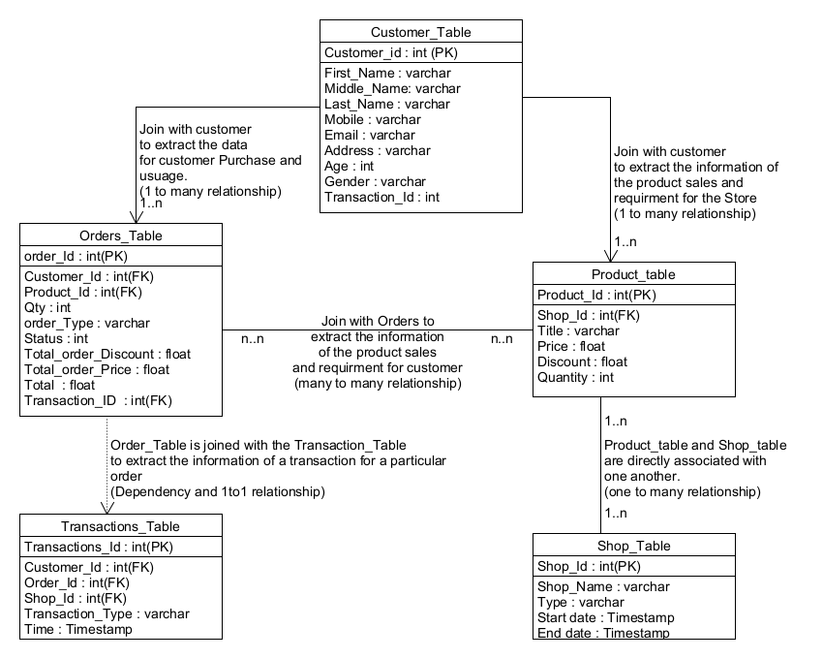

GITHUB link:

<https://github.com/YaminiNannapaneni1/Databasesystems/blob/main/shoping_mall_management_system.pdf>

**Crow’s Foot notation Using Vertabelo:**

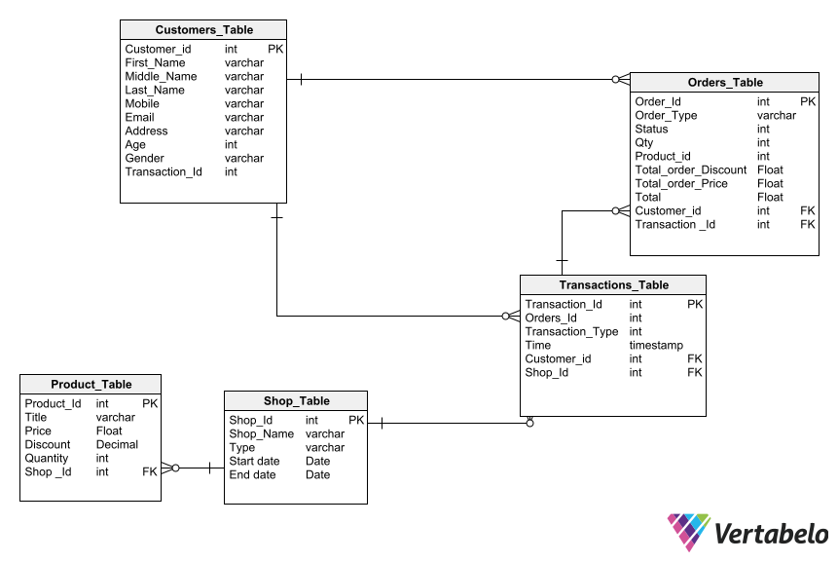

GITHUB Link:

<https://github.com/YaminiNannapaneni1/Databasesystems/blob/main/Shopping_mall-2022-04-02_15-48.png>

**References:**

Customer-user table-

(<https://mysql.tutorials24x7.com/blog/guide-to-design-database-for-shopping-cart-in-mysql>)

Shop owner-

(https://www.yumpu.com/en/document/view/5805733/design-of-shopping-mall-management-system)

Product table-

(<https://mysql.tutorials24x7.com/blog/guide-to-design-database-for-shopping-cart-in-mysql>)

Product review table-

(<https://mysql.tutorials24x7.com/blog/guide-to-design-database-for-shopping-cart-in-mysql>)